Zombie Apocalypse Simulation
Mathematics for Model
This model is based on the YouTube tutorial : https://youtu.be/mwJXjxMTwAw?si=RMQbzf2cvbOeuKnQ
Variables which will be using,
- N – Total Population
- S – Number of susceptible people
- I – Number of infected people
- R – Number of people who have recovered
- ß – Rate of infection
- γ - Rate of Recovery
- t – Time

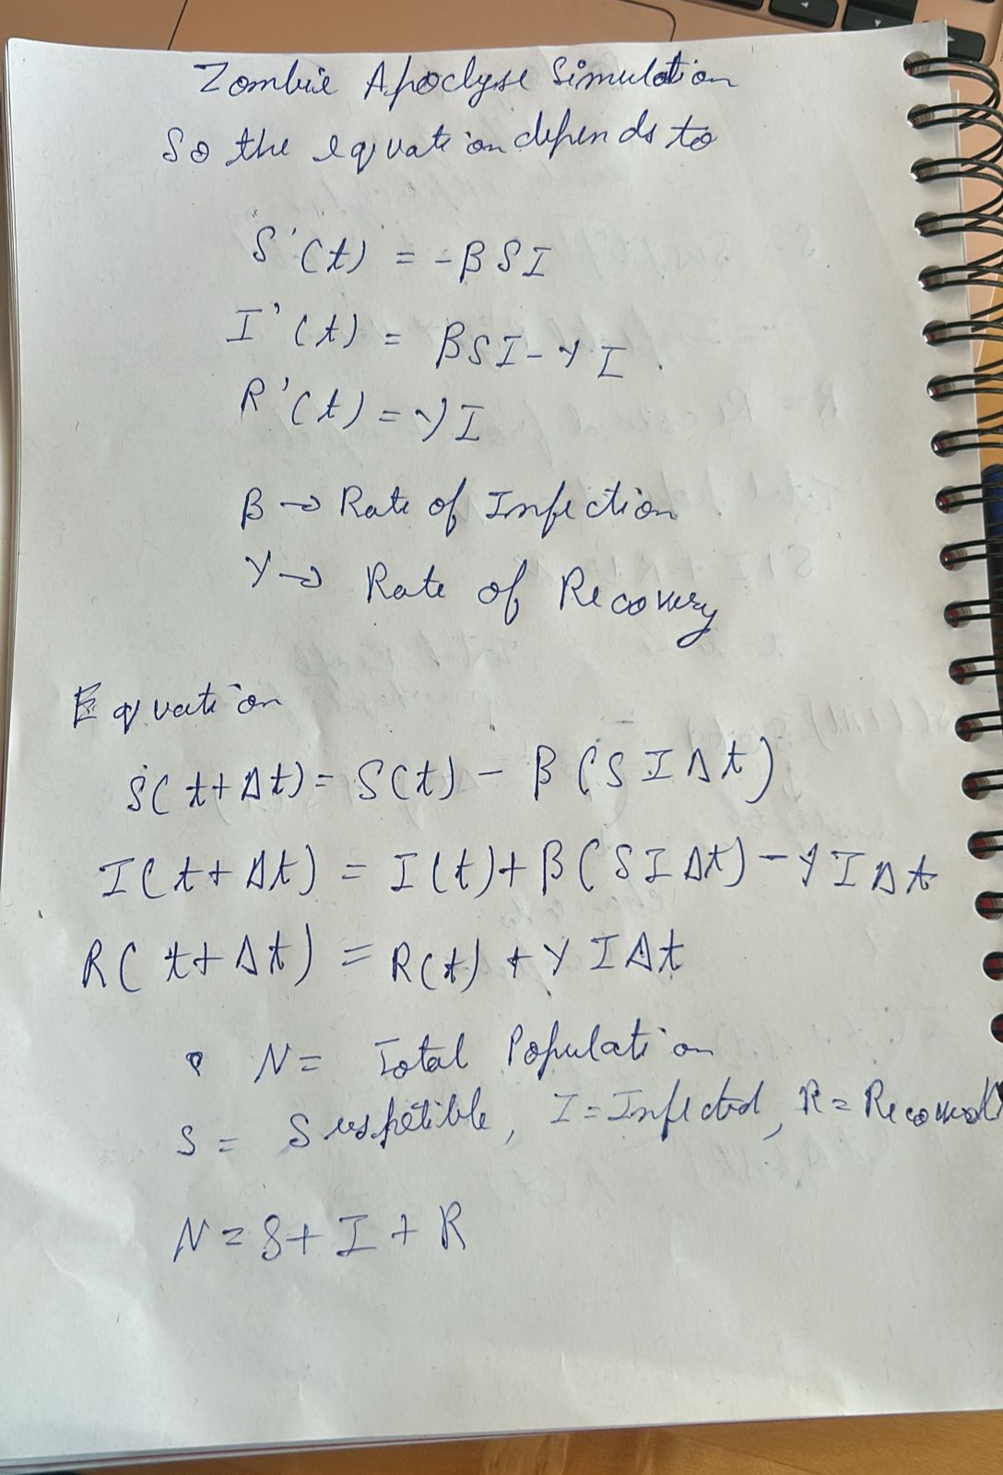

Here the equations at the top are differential equations which gives us
- Change in the susceptible population
- Change in the infected population
- Change in the recovered population
The equations the bottom are the underlying equations for the differential equations that describe the same.
Explanation of Equations created with human in the loop using ChatGPT 5.3
In the SIR model, the population is divided into three groups: susceptible $S(t)$, infected $I(t)$, and recovered $R(t)$, where $t$ represents the current time and $N=S+I+R$ is the total population. $S(t)$ represents the number of individuals who are susceptible to infection at time $t$. After a small time interval $Δt$, the susceptible population becomes $S(t+Δt)$. The decrease in susceptible individuals occurs because some susceptible people come into contact with infected individuals and become infected. The number of new infections is modeled as $βSIΔt$, where $β$ is the infection rate. The term $SI$ appears because infection requires contact between a susceptible person and an infected person; therefore the number of possible transmission events depends on both the number of susceptible individuals and the number of infected individuals. The factor $Δt$ is included because $βSI$ represents the rate of new infections per unit time, so multiplying by the small time interval gives the number of infections occurring during that period. For the infected population, the number of infected individuals after a small time step is $I(t+Δt)=I(t)+βSIΔt-γIΔt$. The first term adds newly infected individuals coming from the susceptible group, while the second term subtracts individuals who recover during the time interval. The recovery process is modeled by $γIΔt$, where $γ$ is the recovery rate and $I$ appears because only infected individuals can recover. Finally, the recovered population increases according to $R(t+Δt)=R(t)+γIΔt$, since recovered individuals come from the infected group at the recovery rate. These equations describe how individuals transition between the susceptible, infected, and recovered compartments over time.

